Test Case: tc002_SPX_Dev5_Crear_Requisicion_Spot_Tipo_Cobro_Project
Step 1 - Enter username and password and click to button Enter: Credentials Entered
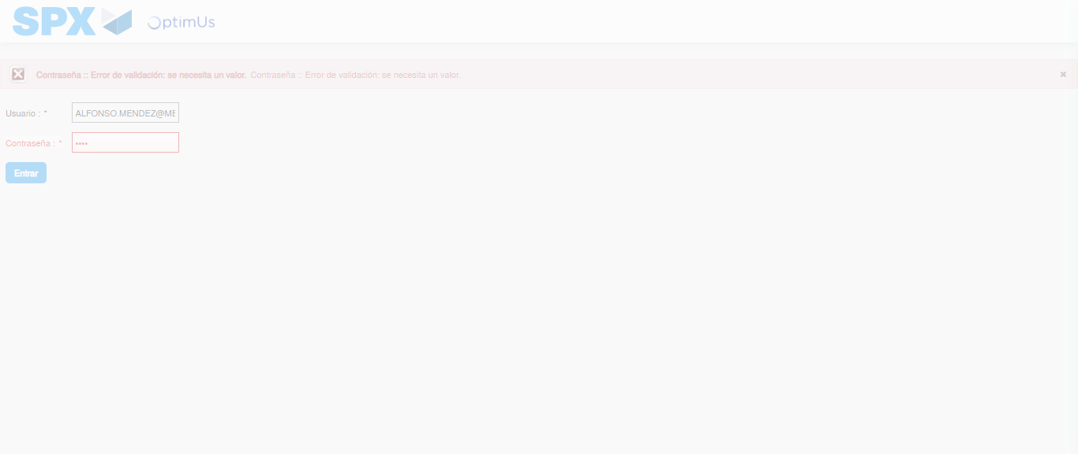Image file-name: QC_Testing-tc002_SPX_Dev5_Crear_Requisicion_Spot_Tipo_Cobro_Project-1783378528416

Step 2 - Select to UEN and Access to Spot Buy Requisitions : UEN Correctly selected and Correct access
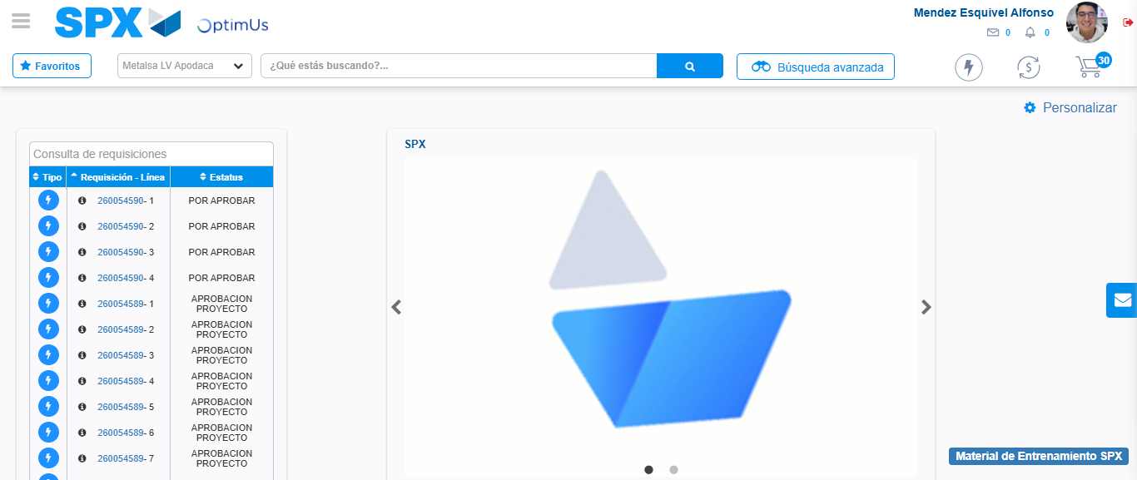Image file-name: QC_Testing-tc002_SPX_Dev5_Crear_Requisicion_Spot_Tipo_Cobro_Project-1783378553406

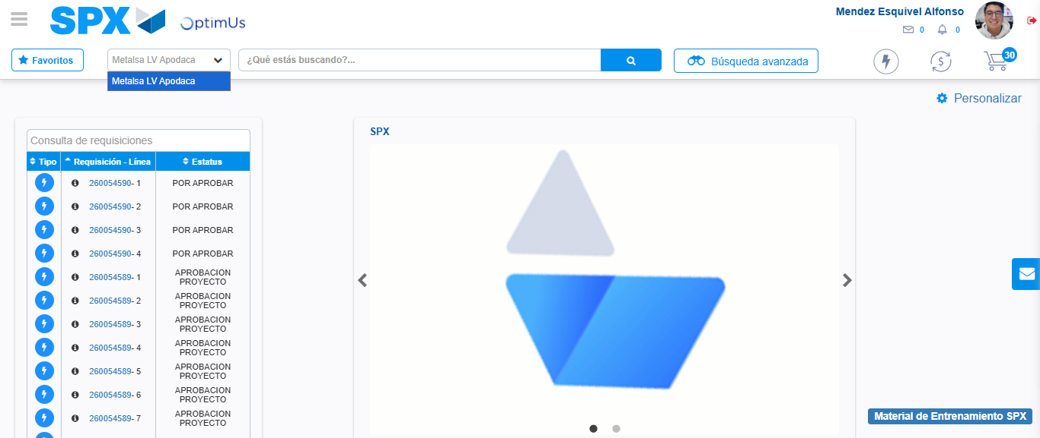Image file-name: QC_Testing-tc002_SPX_Dev5_Crear_Requisicion_Spot_Tipo_Cobro_Project-1783378555820

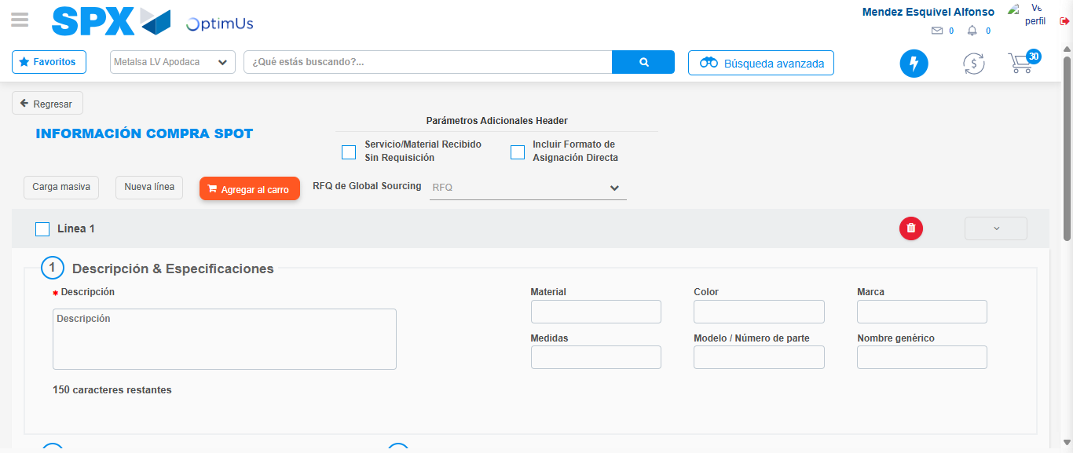Image file-name: QC_Testing-tc002_SPX_Dev5_Crear_Requisicion_Spot_Tipo_Cobro_Project-1783378574359

Step 3 - Data Capture Spot Buy Requisition: Data captured correctly
Image file-name: QC_Testing-tc002_SPX_Dev5_Crear_Requisicion_Spot_Tipo_Cobro_Project-1783378574603

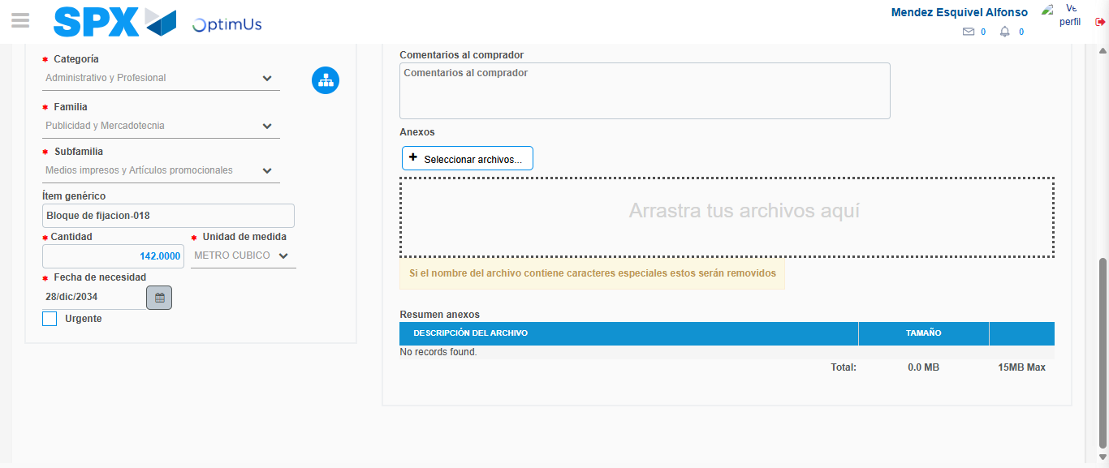Image file-name: QC_Testing-tc002_SPX_Dev5_Crear_Requisicion_Spot_Tipo_Cobro_Project-1783378584804

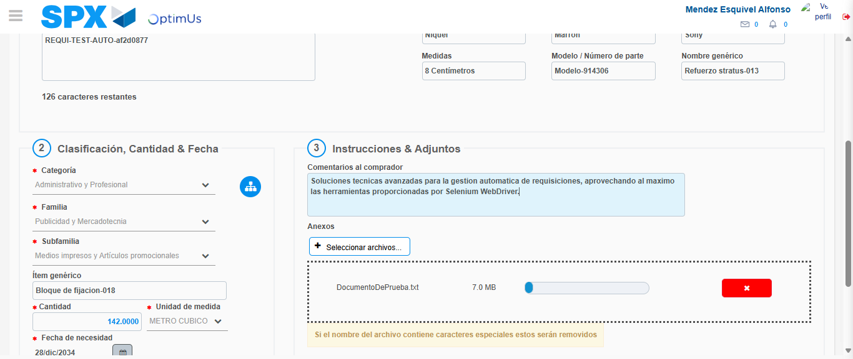Image file-name: QC_Testing-tc002_SPX_Dev5_Crear_Requisicion_Spot_Tipo_Cobro_Project-1783378585583

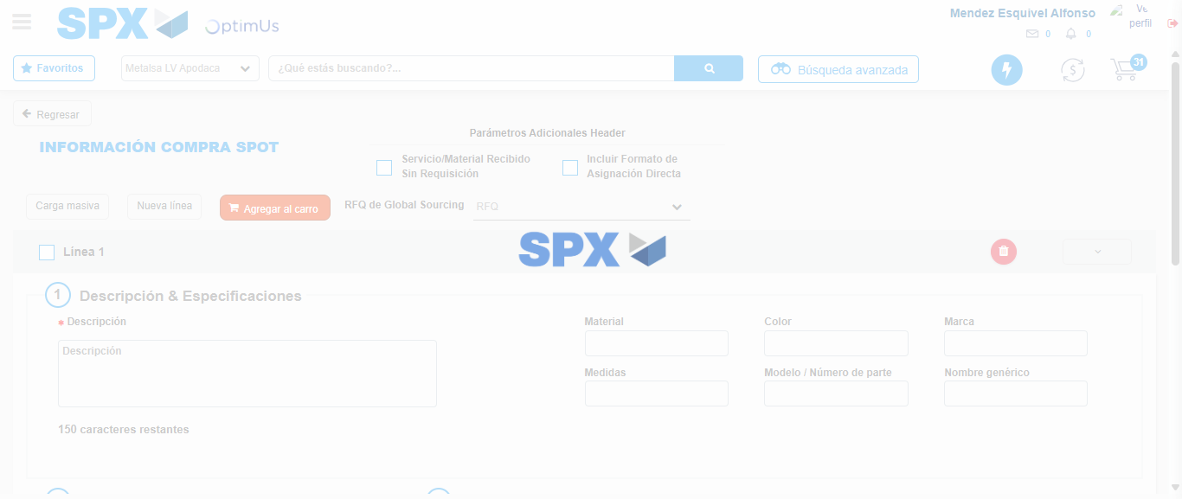Image file-name: QC_Testing-tc002_SPX_Dev5_Crear_Requisicion_Spot_Tipo_Cobro_Project-1783378591440

Step 7 - Return to Main Page SPX : Return to Main Page SPX
Image file-name: QC_Testing-tc002_SPX_Dev5_Crear_Requisicion_Spot_Tipo_Cobro_Project-1783378553406

Image file-name: QC_Testing-tc002_SPX_Dev5_Crear_Requisicion_Spot_Tipo_Cobro_Project-1783378555820

Image file-name: QC_Testing-tc002_SPX_Dev5_Crear_Requisicion_Spot_Tipo_Cobro_Project-1783378574359

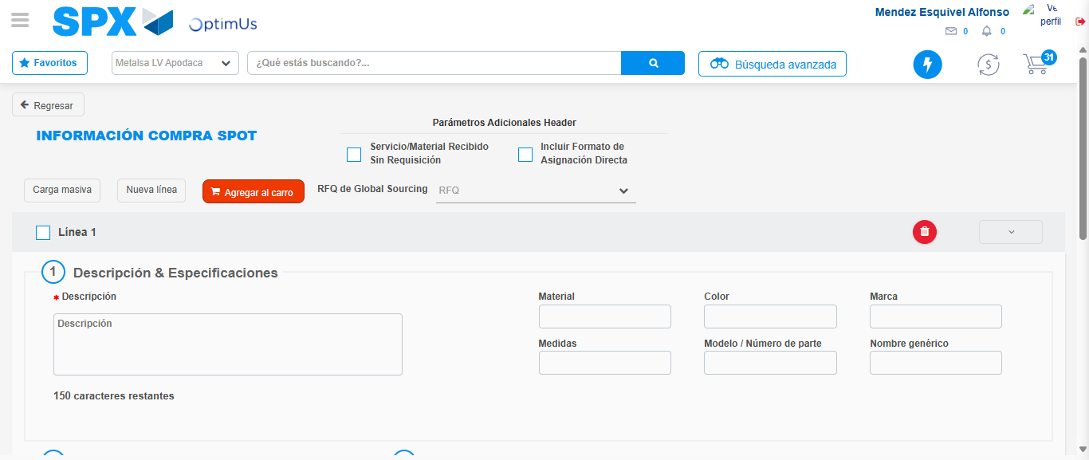Image file-name: QC_Testing-tc002_SPX_Dev5_Crear_Requisicion_Spot_Tipo_Cobro_Project-1783378593668

Image file-name: QC_Testing-tc002_SPX_Dev5_Crear_Requisicion_Spot_Tipo_Cobro_Project-1783378593851

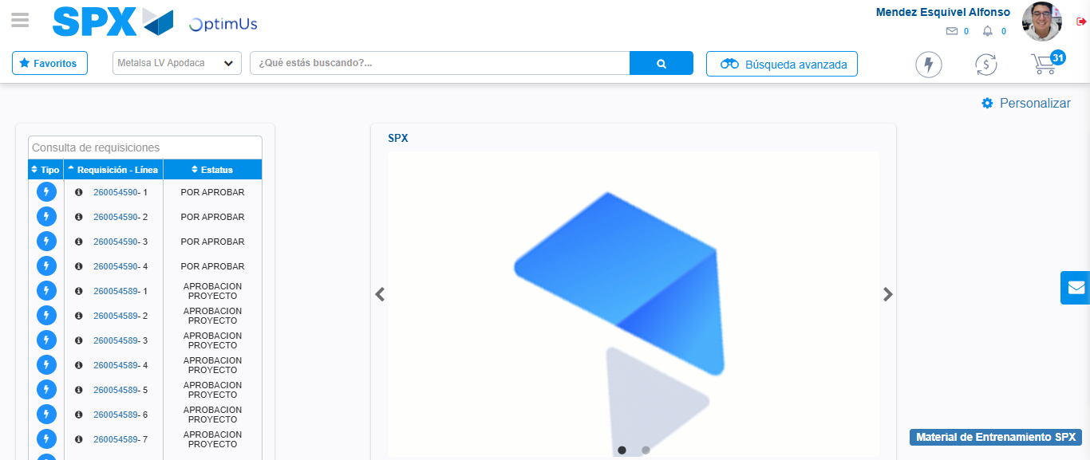Image file-name: QC_Testing-tc002_SPX_Dev5_Crear_Requisicion_Spot_Tipo_Cobro_Project-1783378615025

Step 8 - Log Out : Log Out SPX
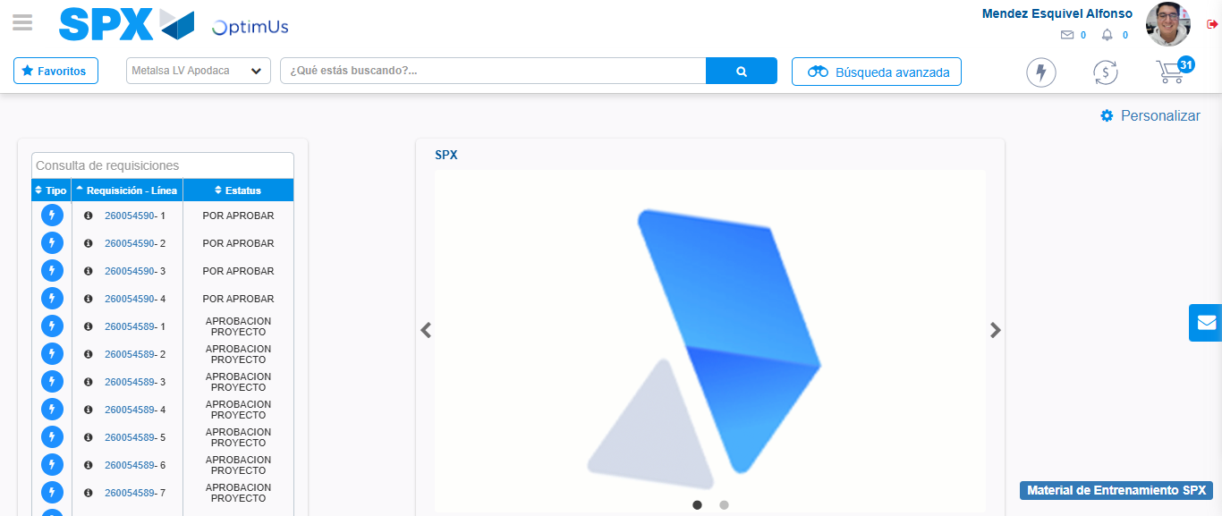Image file-name: QC_Testing-tc002_SPX_Dev5_Crear_Requisicion_Spot_Tipo_Cobro_Project-1783378615262

